PATIENT HEALTH RECORDS
@CREATIVITY THINK (9483175986/7019689991)

ABSTRACT:
Patient Health Records is a web application designed to centralize patient medical data for clinics, hospitals, and individual doctors. Users can log health information, track visits, view test results, and communicate with healthcare providers via a dashboard. Administrators manage records, doctor assignments, analytics, and report exports. The backend utilizes Django and Django Rest Framework for secure data handling, authentication, and business logic, while the frontend employs React, Recharts, and Axios for interactive dashboards and data visualization. This system ensures streamlined patient management and data-driven healthcare oversight..

INTRODUCTION OF THE PROJECT:
Healthcare management requires accurate tracking of patient history, test results, and doctor communications. Patient Health Records provides a web platform for patients to log and monitor their medical information and access dashboards for progress tracking. Administrators manage patient records, oversee doctor assignments, analyze statistics, and export reports. Using Django and Django Rest Framework for backend operations and React with Recharts for frontend visualization ensures secure, interactive, and comprehensive management of patient health data for both users and administrators..

PROJECT OBJECTIVES:

• Enable patients to register and log health information
• Track visits, tests, and results efficiently
• Facilitate communication between patients and doctors
• Provide interactive dashboards for progress visualization
• Allow administrators to manage records and doctor assignments
• Generate analytics and exportable reports
• Improve overall healthcare management and oversight

PROBLEM OF THE STATEMENT:
Managing patient health records manually or in isolated systems can lead to inefficiency, delayed care, and fragmented data. Patients often lack easy access to their own medical history, and healthcare providers struggle to monitor treatments and track progress. This system addresses these challenges by providing a centralized platform where patients can log and access their health information, while administrators manage records, doctor assignments, and analytics, ensuring efficient, accurate, and accessible patient care..

MOTIVATION OF THE PROJECT:
• Centralize patient medical data for easy access
• Improve patient-provider communication
• Track health history, visits, and test results effectively
• Enable administrators to monitor records and generate reports
• Enhance healthcare management and decision-making

BLOCK DAIGRAM OF PROJECT:

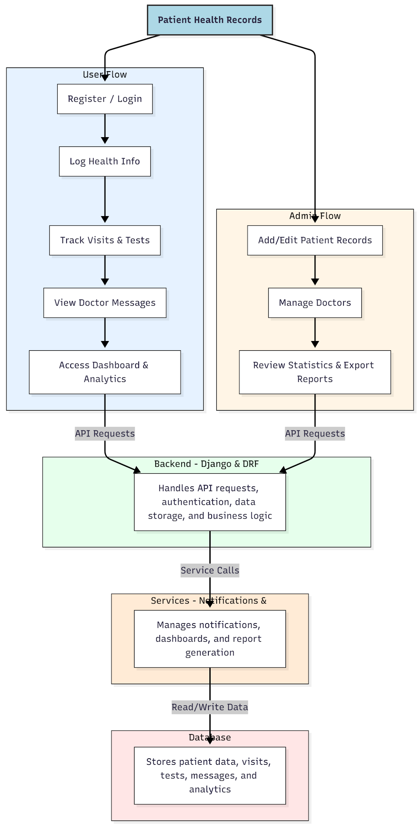

WORKING OF THE PROJECT:
Patients register or log in, input health data, track visits, tests, and view messages from doctors. Dashboards display analytical charts summarizing patient progress. The backend processes API requests, manages authentication, stores records, and executes business logic. Services handle notifications, analytics, and report generation. Administrators add and edit patient records, manage doctor assignments, and review statistics with exportable reports. The system ensures centralized, accessible, and efficient management of patient health information for both users and administrators..

SOFTWARE REQUIREMENT:
- Backend:
  - Python 3.x
  - Django
  - Django REST Framework
  - SQLite/PostgreSQL
- Frontend:
  - Node.js and npm
  - React.js
  - Axios
- Development Tools:
  - Visual Studio Code
  - Postman (for testing APIs)
  - Git/GitHub (for version control)
- Server/Deployment (Optional):
  - Gunicorn, Nginx, or Heroku/AWS for hosting

ADVANTAGES OF THE PROJECT:

• Centralized patient health record management
• Easy logging and tracking of visits and tests
• Real-time communication with doctors
• Interactive dashboards for monitoring health trends
• Administrative control over records and doctor assignments
• Analytics and report export capabilities
• Improves healthcare efficiency and decision-making
• Secure and web-accessible platform

APPLICATIONS OF THE PROJECT:
• Clinics and hospitals for patient record management
• Doctor offices for tracking patient history
• Health monitoring for chronic patients
• Data-driven healthcare analytics
• Telemedicine platforms
• Educational purposes in medical institutions
• Patient progress tracking and reminders
• Centralized dashboard for administrative oversight

REFERENCES:

- Django REST Framework Documentation — Django Software Foundation. Django Documentation. Available: https://docs.djangoproject.com/
- Django REST Framework. DRF Documentation. Available: https://www.django-rest-framework.org/
- React. React Official Documentation. Available: https://reactjs.org/docs/getting-started.html
- Redux. Redux Documentation. Available: https://redux.js.org/introduction/getting-started
- PostgreSQL Global Development Group. PostgreSQL Documentation. Available: https://www.postgresql.org/docs/
- MySQL. MySQL Reference Manual. Available: https://dev.mysql.com/doc/
- Git. Git Documentation. Available: https://git-scm.com/doc
- Node.js. Node.js Documentation. Available: https://nodejs.org/en/docs/
- Axios. Axios Documentation. Available: https://axios-http.com/docs/intro
- Socket.io Documentation – https://socket.io/docs/

